|  |  |  |  |
| --- | --- | --- | --- |
| **Document Number** | **ACNP3** | | |
| **Document Title** | Real Time Ultrasound | | |
| **Department Ownership** | Physiotherapy | | |
| **Document Type** | Procedure | | |
| **Department Owner** | Jason Ryan | | |
| **Document Author** | Derrick Chan | | |
| **Last Edited By** | Derrick Chan | **Lasted Edited On** | 15/05/2015 |

# Purpose

The purpose of the Real Time Ultrasound (RTUS) Clinic is to utilize the use of real time ultrasound to assist in assessment and management of musculoskeletal injuries, including:

* Diagnosis of muscle and tendon tears
* Distinguishing between bursitis and tendinosis
* Diagnosis of tendinopathy
* Core activation
* Dysfunctional muscle activation

The primary focus will initially be on improving core muscle activation in patients with low back pain, or as a precursor to starting Pilates.

# Scope

**This procedure** **applies to all physiotherapists at REDiMED Belmont. RTUS can be used for all patients with low back pain, or any patient as an introduction to Pilates.**

Contraindications:

None

Precautions:

Pregnancy

# Reference Documents

User manual (I:\Physiotherapy\Resources\User Manuals)

WorkCover WA Fees (November 1st, 2014)

Physiotherapy course manual

# Definitions

**RTUS** – Real time ultrasound. A radiological technique for viewing deep structures of the body by recording reflections of ultrasonic waves directed into the tissues

**TA** – Transverse abdominis. A muscle of the abdominal wall, deep to the oblique muscles, which runs from the thoracolumbar fascia to the linea alba in a transverse direction. The transverse abdominis is a component of the core muscles and provides thoracic and pelvic stability.

**PS001** – Specific physiotherapy assessment. Includes specific types of assessments not classified elsewhere in these scales required by the insurer which physiotherapists may undertake (e.g. diagnostic ultrasound imaging, Functional Capacity Assessments (FCE's), seating and wheelchair assessments).

**PW001** – Specific physiotherapy intervention. Includes treatments not classified elsewhere in these scales required by the insurer which physiotherapists may undertake (e.g. treatment of severe multiple area trauma, burns, neurologically injured patients and patients with severe spinal injuries, ergonomic corrections of workplace, specialised real-time ultrasound imaging, short consultations).

**RTUS** – Real Time Ultrasound

**RTUS Coordinator** – Adam Bastick

# Flowcharts (Other Images)

# Procedures

**Using RTUS for specific physiotherapy assessment and treatment**

1. Ensure patient is suitable for RTUS
2. Talk to patient and to get consent to use RTUS
3. Place patients file in RTUS referral tray, located in the physiotherapy office
4. Inform RTUS Coordinator of intention to use RTUS on selected patient
5. Write a letter to patient’s case manager via email of facsimile requesting approval to use RTUS as a specific physiotherapy assessment and treatment tool (Template in Genie):

* Highlight patient’s name and then click on “create or print a merged letter template” button

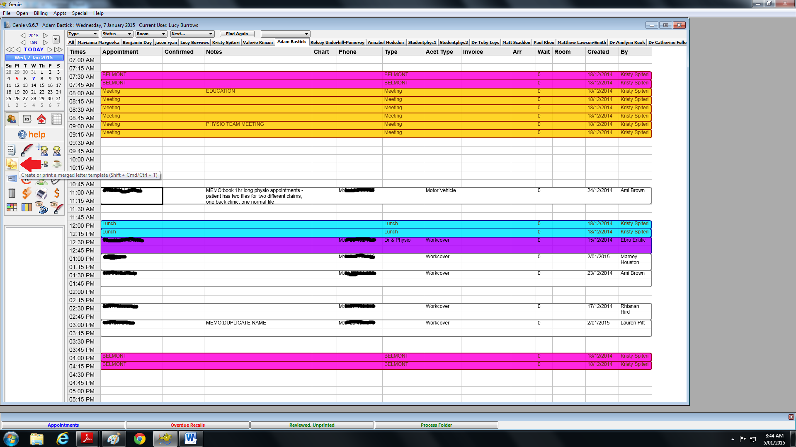

* Then click on “RTUS letter” located under the physiotherapy tab, then click “open”

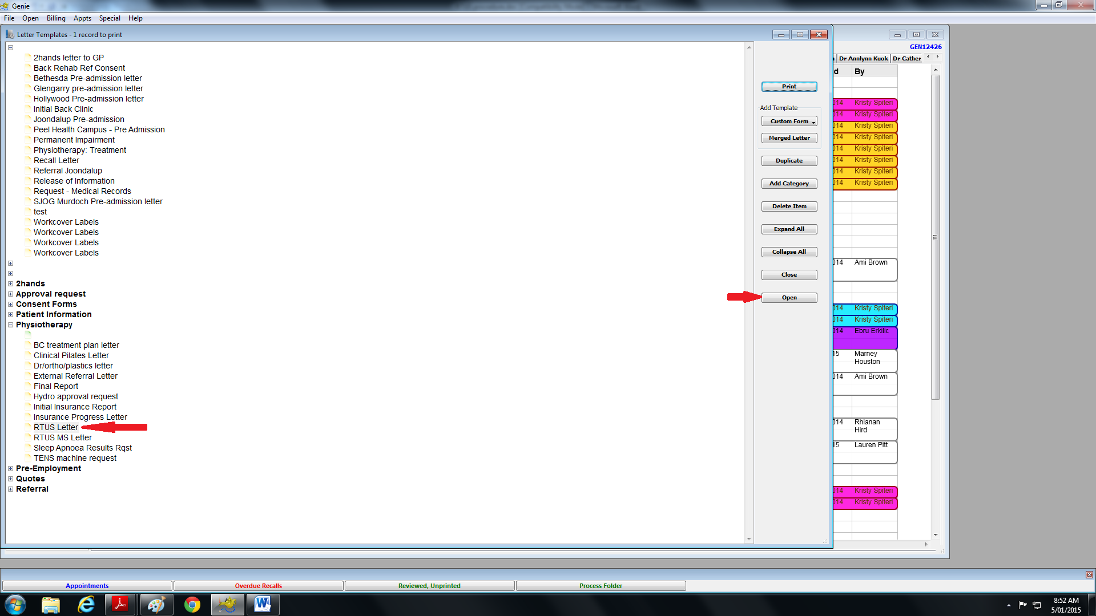

* Click the “auto populate” button and then complete the rest of the letter

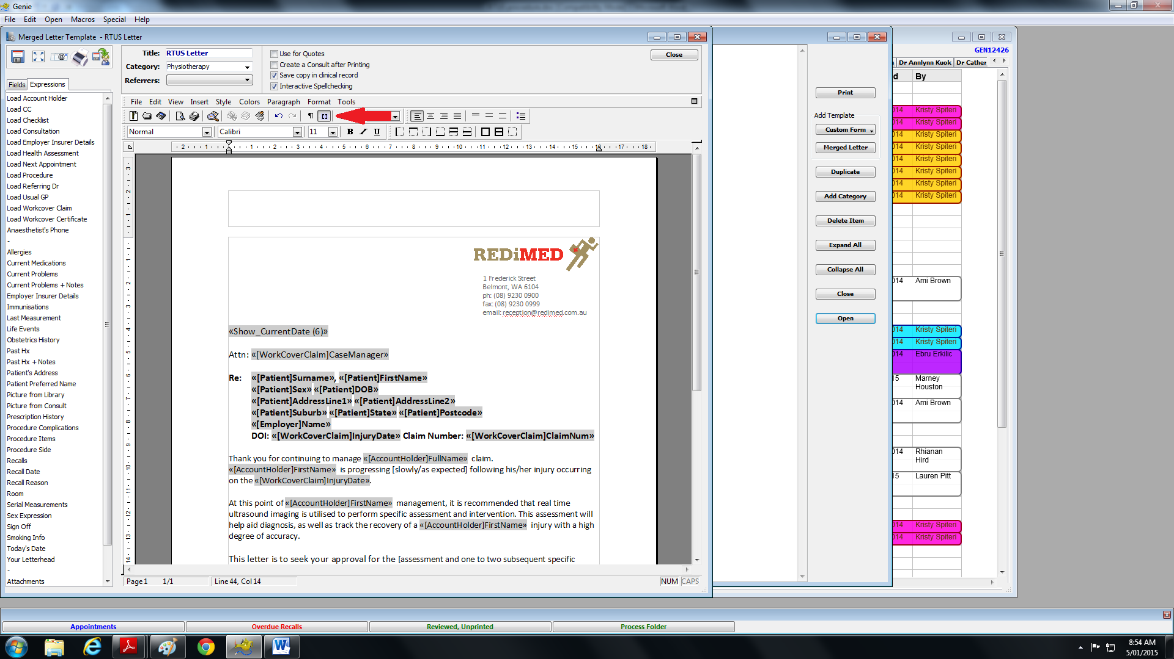

* Save the letter to the patient’s file

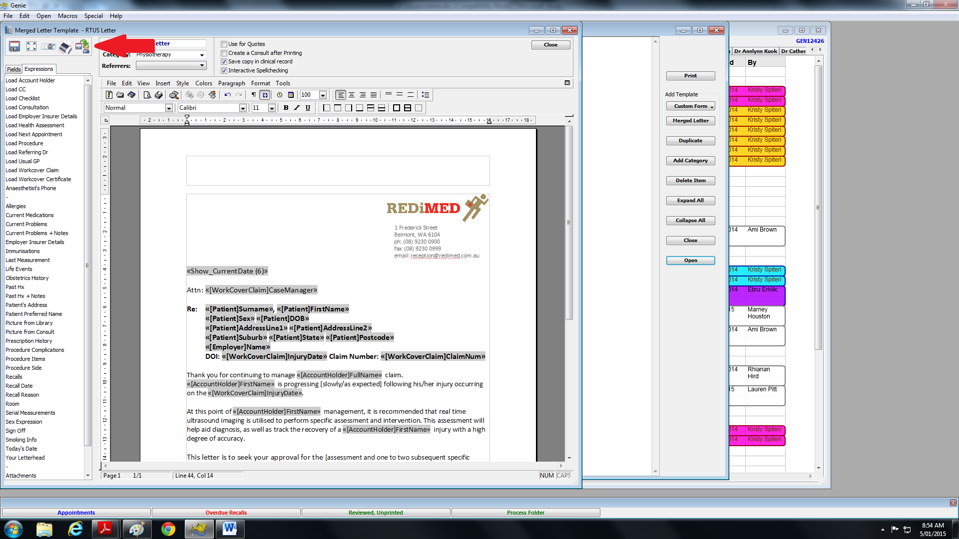

1. Once approved by insurer, schedule appointment with patient at reception, in any time other than Tuesday or Thursday mornings as RTUS machine will not be available then.
   * If there is no response within one week, follow up with the case manager with a phone call
2. Before scheduled appointment time:
   * Retrieve RTUS machine from plastic procedure rooms, located opposite the nursing department
   * Inform nursing staff that you are using the RTUS machine
   * If this is the first assessment, Take a RTUS assessment form from the RTUS referral tray or print off RTUS Assessment form, found in ‘I’ drive.
   * Clean RTUS probe using disinfectant wipe
3. Complete assessment or treatment session
4. Clean RTUS probe with disinfectant wipes once again
5. Return RTUS machine to procedure rooms, located opposite the nursing department
6. Bill patient in Genie using specific physiotherapy assessment (PS001) or treatment (PW001) codes. Approval is required if total treatment time is greater than 2 hours.

# Appendices

RTUS TA Assessment form

Letter to the Insurer

Initial exercise program



**Date  
RTUS – Transverse Abdominis Assessment Form**

|  |  |  |  |  |
| --- | --- | --- | --- | --- |
|  | **Left** | | **Right** | |
| Relaxed | Contracted | Relaxed | Contracted |
| Transverse Abdominis Thickness |  |  |  |  |
| Internal Oblique Thickness |  |  |  |  |

|  |  |  |
| --- | --- | --- |
| **TrA Activation in Crook Lying** | **Left** | **Right** |
| Is there a lateral slide of TrA? | Yes / No | Yes / No |
| Does TrA increase in thickness? | Yes / No | Yes / No |
| Is there an increase in internal oblique activity? | Yes / No | Yes / No |
| Does TrA relax after contraction? | Yes / No | Yes / No |
| Could TrA contraction be maintained with normal respiration? | Yes / No  How many breaths: | Yes / No  How many breaths: |

|  |  |  |
| --- | --- | --- |
| **TrA Activation with Bent Knee Fall-Out** | **Left** | **Right** |
| Is TrA active throughout task? | Yes / No | Yes / No |
| Is there altered internal oblique activation? | Yes / No | Yes / No |
| Does TrA relax after task? | Yes / No | Yes / No |
| How many repetitions before TrA fatigued? |  |  |

|  |  |  |
| --- | --- | --- |
| **TrA Activation with Heel Slide** | **Left** | **Right** |
| Is TrA active throughout task? | Yes / No | Yes / No |
| Is there altered internal oblique activation? | Yes / No | Yes / No |
| Does TrA relax after task? | Yes / No | Yes / No |
| How many repetitions before TrA fatigued? |  |  |

|  |  |  |
| --- | --- | --- |
| **TrA Activation with Active Straight Leg Raise** | **Left** | **Right** |
| Is TrA active throughout task? | Yes / No | Yes / No |
| Is there altered internal oblique activation? | Yes / No | Yes / No |
| Does TrA relax after task? | Yes / No | Yes / No |
| Able to hold TrA for 10 seconds? | Yes / No | Yes / No |

**Letter to Insurer**

«Show_CurrentDate (6)»

Attn: «[WorkCoverClaim]CaseManager»

**Re: «[Patient]Surname», «[Patient]FirstName»**

**«[Patient]Sex» «[Patient]DOB»**

**«[Patient]AddressLine1» «[Patient]AddressLine2»**

**«[Patient]Suburb» «[Patient]State» «[Patient]Postcode»**

**«[Employer]Name»**

**DOI: «[WorkCoverClaim]InjuryDate» Claim Number: «[WorkCoverClaim]ClaimNum»**

Thank you for continuing to manage «[AccountHolder]FullName» claim. «[AccountHolder]FirstName» is progressing [slowly/as expected] following his/her injury occurring on the «[WorkCoverClaim]InjuryDate».

At this point of «[AccountHolder]FirstName» management, it is recommended that real time ultrasound imaging is utilised to perform specific assessment and intervention. This assessment will help aid diagnosis, as well as track the recovery of a «[AccountHolder]FirstName» injury with a high degree of accuracy.

This letter is to seek your approval for the [assessment and one to two subsequent specific treatment sessions] to go ahead. Please provide notice of approval, either via fax (9230 0999) or email ([email@redimed.com.au]).

**Code Description Cost**

PS001 Specific Physiotherapy Assessment $183.10

PW001 Specific Physiotherapy Intervention $183.10

PW001 Specific Physiotherapy Intervention $183.10

If you have any further questions, please don't hesitate to contact me.

Regards,

Name

Physiotherapist

email@redimed.com.au

**Initial Exercise Program**

